EXPERIMENT E3.1: DYNAMIC OR TUNED VIBRATION ABSORBER

LOG SHEET

Name: ___E________________________________________

Date: _________________ Time: AM / PM

Submit To: ___________________________________________

Spring stiffness of primary system

Dial gauge at point A |  |  | Dial gauge at point B
Micrometer $δ_{o}$ (mm) = 0 |  |  | Micrometer $δ_{o}$ (mm) = 0
M (kg) | $δ$ (mm) | $δ$ - $δ_{o}$(mm) | M (kg) | $δ$ (mm) | $δ$ - $δ_{o}$(mm)
1 | 0.36 | 0.36 | 1 | 0.38 | 0.38
2 | 0.71 | 0.71 | 2 | 0.73 | 0.73
3 | 1.08 | 1.08 | 3 | 1.09 | 1.09
4 | 1.44 | 1.44 | 4 | 1.47 | 1.47
5 | 1.81 | 1.81 | 5 | 1.83 | 1.83
6 | 2.18 | 2.18 | 6 | 2.22 | 2.22

Plot a graph from the above table.

Dynamic displacement of primary system

$ω$ (rpm) | x (mm) | $ω$ (rpm) | x (mm)
530 | 0.02 | 1261 | 0.43
622 | 0.04 | 1313 | 0.32
710 | 0.06 | 1351 | 0.28
750 | 0.07 | 1396 | 0.24
808 | 0.10 | 1440 | 0.22
893 | 0.17 | 1513 | 0.19
940 | 0.22 | 1578 | 0.17
1011 | 0.34 | 1636 | 0.16
1113 | 1.24 | 1681 | 0.16
1155 | 1.22 | 1732 | 0.15
1203 | 0.68 | 1758 | 0.15
1227 | 0.54 | 1842 | 0.14
Dynamic displacement of composite system

$ω$ (rpm) | x (mm) | $ω$ (rpm) | x (mm)
509 | 0.02 | 1307 | 1.28
610 | 0.05 | 1379 | 0.98
670 | 0.08 | 1439 | 0.64
727 | 0.22 | 1484 | 0.43
786 | 0.30 | 1555 | 0.31
850 | 0.08 | 1592 | 0.27
920 | 0.01 | 1658 | 0.23
997 | 0.03 | 1688 | 0.21
1058 | 0.06 | 1720 | 0.20
1118 | 0.09 | 1742 | 0.19
1194 | 0.18 | 1797 | 0.18
1255 | 0.38 | 1849 | 0.17

Plot a graph from the above tables.

Natural frequency of absorber system.

No. | $ω_{n}$ (Hz)
1 | 15.81
2 | 15.84
3 | 15.80
Average: | 15.82

Discussion

- Comment on the spring stiffness of the system.

The graph shows a general linear relationship between mass and deflection. This shows that the equation $F=-k∆x$ is satisfied, hence satisfying Hooke’s law.

- What are the resonant frequencies of the primary and composite systems? Hence comment on the vibration absorber’s effectiveness.

$1113×2π = 6993.18 rad/min$
$\frac{6993.18}{60}= 116.55 rad/s$
$\frac{116.55}{2π} = 18.55Hz$

Hence the resonant frequency of the primary system is 18.55Hz.

$\frac{1307 }{60}= 21.73Hz$
$\frac{786}{60} = 13.1Hz$
Hence the resonant frequencies of the composite systems are 13.1Hz and 21.73Hz.

The effectiveness of the vibration absorber is only good at the motor speed between 920rpm and 1307rpm where the resonant frequency of the primary system occurs.
This shows that the vibration absorber is only efficient if motor is to work within that range.

Discussion

c) Calculate the theoretical natural frequency of the vibration absorber and compare it with the experimental value. Comment on your result.

Theoretical:
$ω_{n}= {(\frac{3EI}{(M+\frac{33ρAL}{140})L^{3}})}^{\frac{1}{2}}$ $\frac{rad}{s}$

E = 201Gpa = $201×{10}^{9}$pa
ρ = 7860kg/m³
m = 23gm = 0.023kg
L = 410mm = 0.41$m$
$A=πr^{2}$ = ${(\frac{0.006}{2})}^{2}π$ = $(9×{10}^{-6})π$ $m^{2}$

$I=\frac{1}{4}πr^{4}$
= $(2.025×{10}^{-11})π$ $m^{3}$

$ω_{n}= {(\frac{3(201×{10}^{9})(2.025×{10}^{-11})π}{(0.023+\frac{33(7860)(9×{10}^{-6})π(0.41)}{140}){0.41}^{3}})}^{\frac{1}{2}}$

= 111.866 $\frac{rad}{s}$

Experimental:

Natural Frequency = $2πf$
= $15.817×2π$
= $31.634π$ $\frac{rad}{s}$

Percentage Error:
$\%error$ = $\frac{Theoretical-Experiemental}{Theoretical}×100\%$
= $\frac{111.866-31.634π}{111.866} × 100\%$
= 11.16 $\%$

The experimental error could be due to inaccuracy of recording of result due to human error when looking at the dial indicator. Another possible reason could be due to fluctuation of readings from tachometer due to vibration.

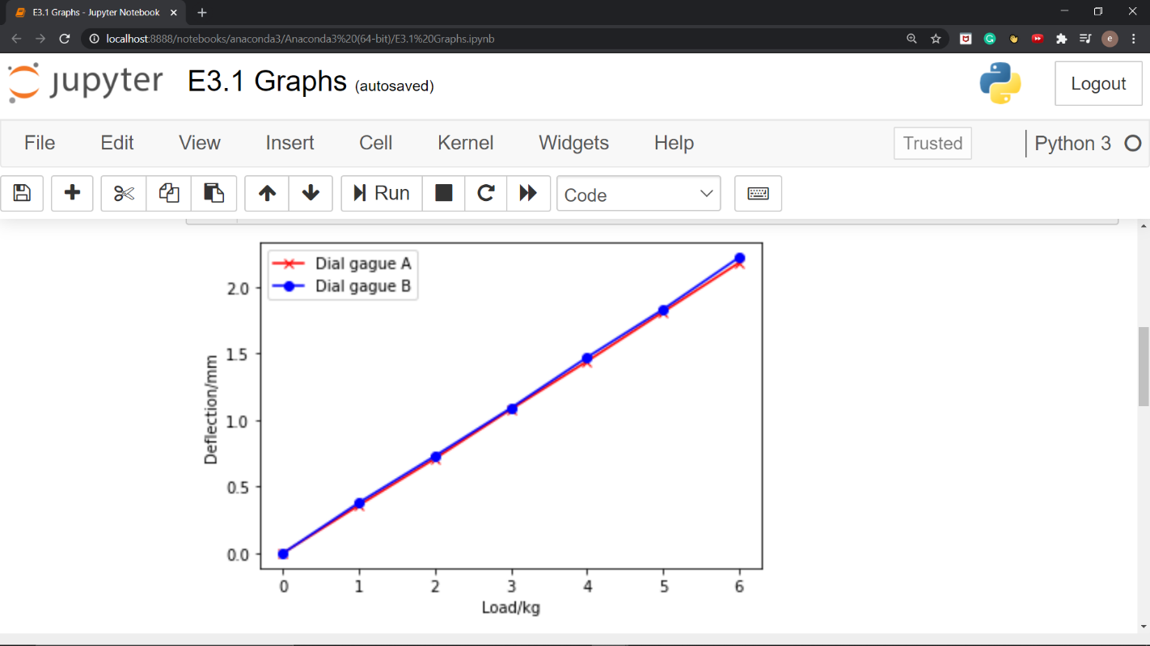

Table 1: Spring Stiffness of primary system

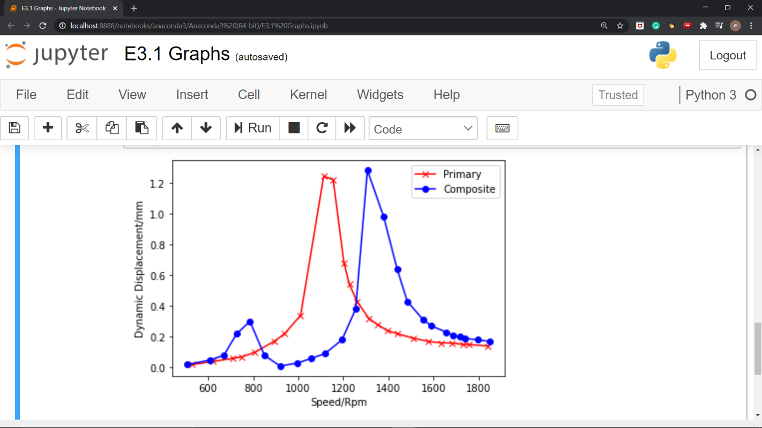
Table 2: Displacement vs Rpm

